**Name: Darshan Soni**

**Batch: TY-CSF 1**

**Roll no: 2213273**

**Assignment 6**

**Aim :** PL/SQL: Procedures and Functions.

1. Write a function to square the number taken from user.
2. Write a procedure to display the records from Manufacturing industry / Hospital/ Company table

**Theory :**

PL/SQL (Procedural Language/Structured Query Language) offers two key constructs: procedures and functions, both serving distinct purposes:

**Procedures**:

Procedures are blocks of code that can accept input parameters but do not return values directly.

They are primarily used for performing tasks, such as data manipulation, without returning a result to the caller.

Procedures are invoked using the CALL statement or as part of another PL/SQL block.

They are suitable for tasks like database maintenance, data validation, and executing complex SQL operations.

**Functions**:

Functions, like procedures, can accept input parameters, but they must return a single value.

They are designed for computations or tasks that yield a result.

Functions are called as part of SQL expressions, providing a way to incorporate custom logic within SQL statements.

They are ideal for tasks like calculations, data retrieval, and generating values for queries.

**Implementations :**

**A:**

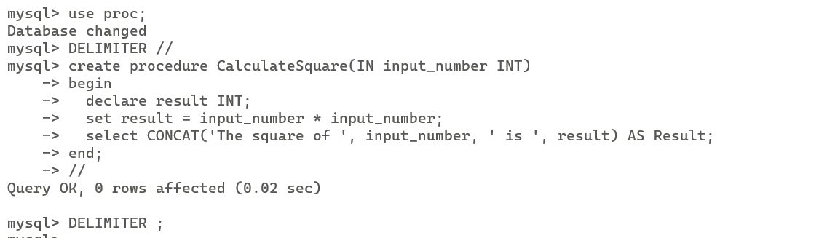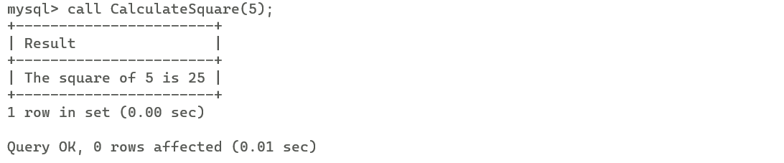

**B:**

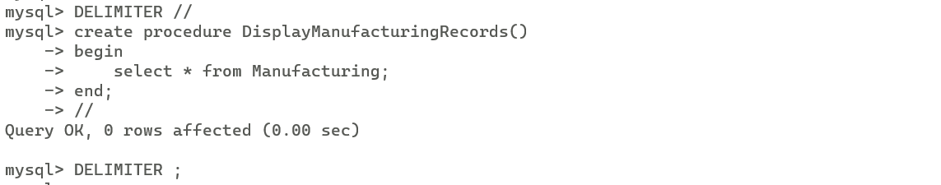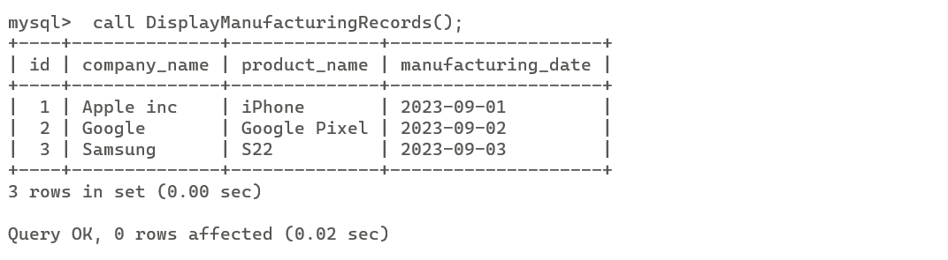

**Conclusion :** The provided MySQL procedure and table creation commands enable the display of records from the Manufacturing industry table and can be adapted to suit specific data and business needs.